Supplementary Figures
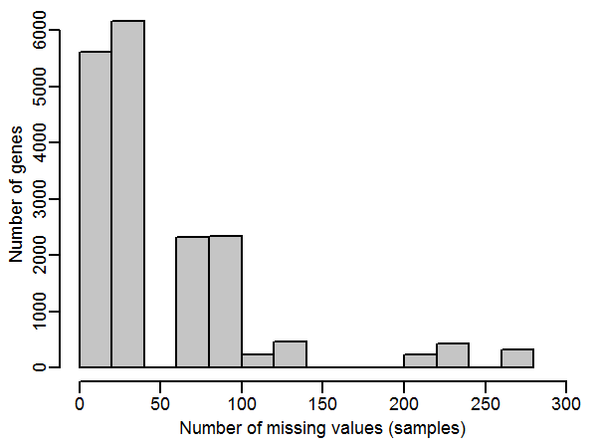
Supplmentary Figure 1. Histogram of genes with missing values. The x-coordinate indicates how many samples have missing values. This study was collected 1411 samples and the total number of genes is 18116. The figure shows that most of the sample's expression data is relatively complete (80% samples have no missing value, 13% samples have less than 3% missing values, only 7% samples have more than 10% missing values).

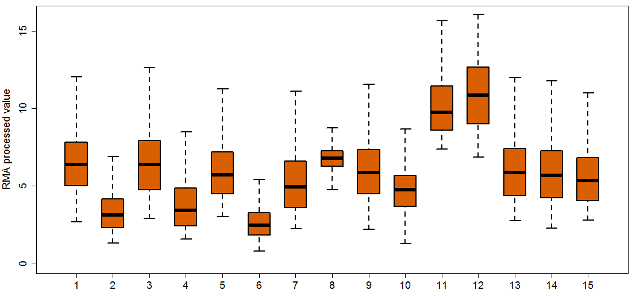
Supplementary Figure 2. The distribution of RMA processed gene expression values of lymphoma datasets. The orange box shows the distribution of gene expression values in lymphoma patients and the green box shows the distribution of gene expression values in controls. There was a relatively large deviation in the distribution of gene expression values across these studies.

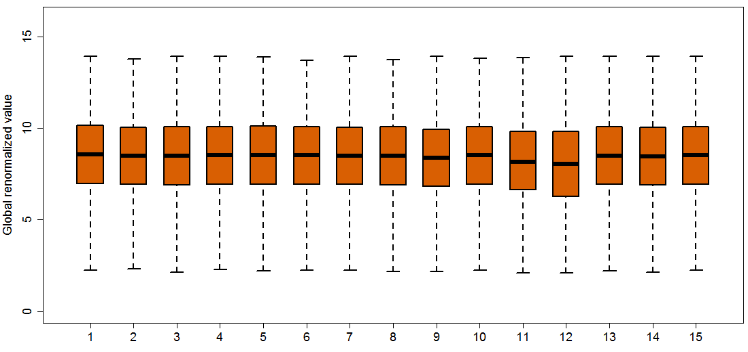
Supplementary Figure 3. The distribution of global renormalized (after RMA processed) gene expression values of lymphoma datasets. The orange box shows the distribution of gene expression values in lymphoma patients and the green box shows the distribution of gene expression values in controls. The distribution of gene expression values across these studies had a consistent range.

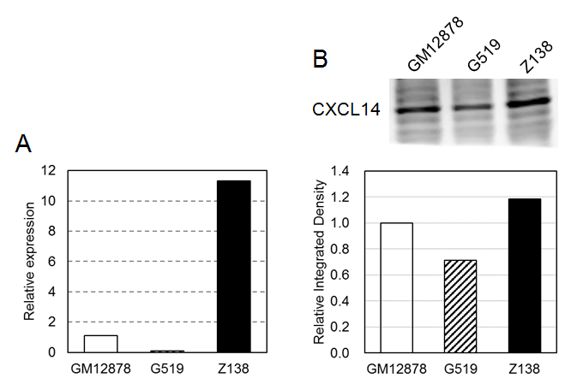
Supplementary Figure 4. CXCL14 expression in normal B cell line (GM12878) and MCL cell lines (Z138 and G519). (A) RT-qPCR results of CXCL14 mRNA level in three cell lines. (B) Western blot results of CXCL14 mRNA level in three cell lines. The bar plot showed the quantified band intensities.

